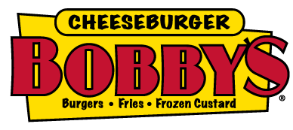

Dear New Team Member,
Congratulations and welcome to Cheeseburger Bobby’s! We are delighted you have joined our team and are looking forward to assisting you as you become familiar with your new surroundings. There will be much to learn about the procedures at Cheeseburger Bobby’s and you will soon begin this process, but first, we would like to share something we feel is even more important than our procedures, our VALUES. Since you are reading this letter, this means we saw exceptional characteristics in you that reflect the values we have at Cheeseburger Bobby’s. It is important to us that we share the same ideas as to how we want to represent ourselves and Cheeseburger Bobby’s in our community. We feel you can perform your job best when you know upfront the key behaviors we expect from team members. Below we have listed the most important behaviors and attributes we seek and admire in the people we choose to work with at Cheeseburger Bobby’s.
- We admire people who work hard. You must be able to pull your own weight, always be willing to help others as well as ask and accept help from managers and coworkers.
- We admire people who do their best to demonstrate positive attitudes. Everyone has a bad day, but I have yet see a day get better by complaining to coworkers, friends, and worst yet, guests about your troubles.
- We admire well organized people who are well groomed and dressed appropriately. These people show up early and have the necessary materials ready to immediately begin providing an extraordinary dining experience for our guests.
- We admire kind people with genuinely nice manners who treat others the way they would like to be treated. We cannot work with those who are argumentative and pass responsibility or blame to others. You must be honest.
- Most of all, we admire those who have respect for themselves, their coworkers, our guests and in the job they do. If you are respectful, the other four behaviors mentioned above will automatically be part of your daily life.
We are confident that you feel these behaviors are just as important as we do, or we would not have chosen you to help us build our company. We value and appreciate your time and hard work and understand how vital each team member is to the success of Cheeseburger Bobby’s. Thank you for choosing us, and we look forward to working with you!
Sincerely,
Bob Stoll

