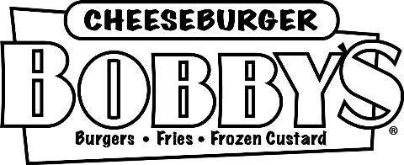

Employee Warning Notice

Employee Information
Employee Name: |  |  |  |  |  |  |  |  |  | Date:
Job Title: |  |  |  |  |  |  |  |  |  | Manager:

Type of Warning
 | First Warning |  |  |  |  |  |  |  | Second Warning |  |  |  |  | Final Warning

Type of Offense
 | Tardiness/Leaving Early |  |  |  |  |  |  |  | Absenteeism |  |  |  |  | Violation of Company Policies
 | Substandard Work |  |  |  |  |  |  |  | Violation of Safety Rules |  |  |  |  | Rudeness to Customers/Coworkers
 | Other:

Details
Description of Infraction:
Plan for Improvement:
Consequences of Further Infractions:

Acknowledgement of Receipt of Warning
By signing this form, you confirm that you understand the information in this warning. You also confirm that you and your manager have discussed the warning and a plan for improvement. Signing this form does not necessarily indicate that you agree with this warning.
Employee Signature |  |  |  |  |  |  |  |  |  |  |  |  |  | Date
Manager Signature |  |  |  |  |  |  |  |  |  |  |  |  |  | Date
Witness Signature (if employee understands warning but refuses to sign) |  |  |  |  |  |  |  |  |  |  |  |  |  | Date

